Literature Review: Smart Energy Distribution
- Introduction:
This project focuses on harnessing Machine Learning (ML) algorithms for forecasting energy demand and dynamically balancing energy distribution in smart grids. The increasing global demand for energy and the imperative to enhance distribution efficiency underscore the significance of this research. ML-driven solutions offer the potential to optimize energy efficiency, reduce wastage, and contribute to sustainable energy practices.
In the face of escalating energy demand and the need for sustainable solutions, this research addresses critical challenges. ML-driven forecasting and dynamic balancing present an innovative approach to enhance the reliability and sustainability of energy systems, adapting in real-time to demand fluctuations.
A succinct literature review is essential to position this research within the broader context of energy management and ML applications. Examining prior studies allows us to glean insights, identify gaps, and understand best practices. This project contributes to the evolving field by synthesizing knowledge, advancing ML applications in energy management for more efficient and sustainable energy distribution systems.
- Organization:
1. Foundations of Energy Forecasting:

- Literature Example: "Comprehensive review of load forecasting with emphasis on intelligent computing approaches"by Hong Wang , Khalid A. Alattas, Ardashir Mohammadzadeh, Mohammad Hosein Sabzalian , Ayman A. Aly , Amir Mosavi. (2022)
-Literature Example: "Machine Learning Techniques and Smart Grid Applications: A Review" by William Sanchez-Huertas , Víctor Gómez , Cesar Hernández
- This paper provides a comprehensive overview of traditional energy forecasting methods and sets the stage for the integration of machine learning.

2. Machine Learning Applications in Energy Management:
- Literature Example: "Renewable energy management in smart grids by using big data analytics and machine learning." by Noha Mostafa, Haitham Saad Mohamed Ramadan, Omar Elfarouk

- Literature Example: " Machine Learning based Energy Management Model for Smart Grid" by S. Raja; Anita Gehlot; M. Kalyan Chakravarthi; Kumud Pant; Shikha Kuchhal; Sivakumar Sattanathan

3. Challenges and Future Directions:

- Literature Example: "Prospects and Challenges of the Machine Learning and Data-Driven Methods for the Predictive Analysis of Power Systems: A Review" by Wadim Strielkowski , Andrey Vlasov, Kirill Selivanov, Konstantin Muraviev and Vadim Shakhnov
- Addressing challenges, this paper discusses the application of machine learning in energy-efficient buildings and provides insights into future research directions.
- Summary and Synthesis:
"Prospects and Challenges of the Machine Learning and Data-Driven Methods for the Predictive Analysis of Power Systems: A Review"
This publication, recall all the methods and type of use of Machine Learning and data analysis in Energy control. About power and energy systems it says that they are designed to deliver electricity to consumers with high reliability and efficiency [6,7]. Predictive analysis plays a critical role in ensuring the reliable and efficient operation of power systems. It involves the use of historical data and statistical models to predict potential issues, such as equipment failures, and plan for optimal operation .(Machine Learning and Data-Driven Methods in Power Systems).
The review explain also the importance of smart grids use and its efficency. In general terms, smart grids are intelligent electric power systems that use advanced technologies such as sensors, smart meters, communication networks, and computers to optimize the energy use [21,22](Smart Grids) Compared to the conventional energy systems, smart grids are characterized by their active nature, which results from the two-way power and information flow enabled by the integration and contribution of every distributed and renewable energy resource. The conventional energy systems are passive due to the unidirectional power and communication flow (Traditional Power Grids and Smart Grids)
Unsupervised machine learning helps data centers cluster large amounts of data for better visibility and applications, while supervised ML is used for more specific tasks such as forecasting or control applications. Reinforcement learning is also used in order to optimize and control the IoE in power grids [122,123].
In addition, there are artificial neural networks (ANNs) which represent the modern machine learning algorithms that use deep neural networks with massive datasets and high dimensional data to create much simpler models.(Machine Learning Methods in Power Systems)
For instance, ANNs have been used for short-term load forecasting with high accuracy, while support vector machines (SVMs) have been applied to fault detection and diagnosis in power systems [171,172]. (Using Machine Learning in Smart Grids)
The smart grid architecture incorporates advanced sensors and control systems that facilitate bidirectional communication and power flow between different components of the system. Smart grid systems have numerous benefits that make them an attractive option for the future of energy. Future research should focus on addressing these challenges and developing more effective market design approaches for the IoE. Such applications as peer-to-peer (P2P) electricity generation and trading (some of them are already being used) might represent the future of the independent smart grids and the autonomic power systems, and therefore they need more attention from the researchers and academics. (Conclusions an Recommendations)
Machine Learning Techniques and Smart Grid Applications: A Review
This review mainly work differents techniques of ML and their applications on Smart Grid.
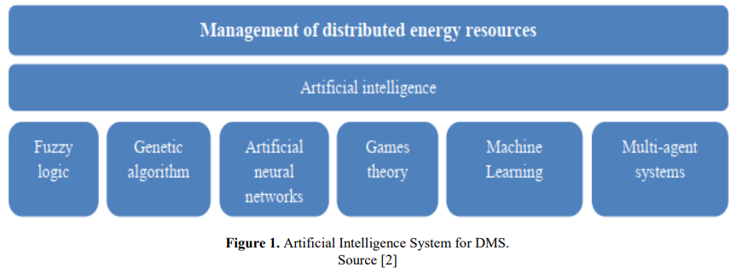
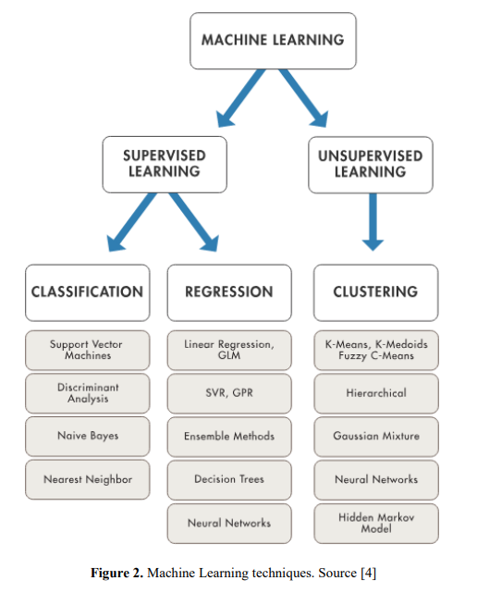

Support Vector Machines (SVM)
Support vector machines (SVM) come from the work on stochastic learning theory and were introduced in the 90s by Vapnik and his colleagues [5]. Although SVM were originally conceived for solving binary classification problems, they are currently used to solve other types of problems (regression, grouping, multiclass classification). There are several fields in which SVM have worked successfully such as computer vision, character recognition, text and hypertext categorization, protein classification, natural language processing and time series analysis. In fact, since their introduction, they have earned a well-deserved recognition thanks to their solid theoretical foundation [6].
Precision (C1), Training time (C2), Linearity (C3), Number of parameters (C4), Frequency of use (C5), Level of combination with other Machine Learning techniques (C6), Sensibility (C7), Accuracy (C8)
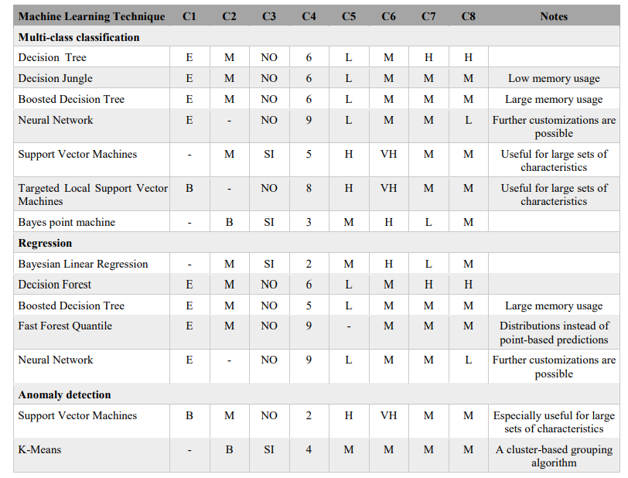

Renewable energy management in smart grids by using big data analytics and machine learning
Unlike fuel-based energy power stations, renewable energy requires more advanced management of power, balancing, and production capacity, which can be achieved by using smart grids (Rathor & Saxena, 2020). These grids integrate traditional power grids with advanced Information Technology (IT) and communication networks to deliver electricity with improved efficiency and reliability, while reducing cost and environmental impacts (Yan et al., 2013).
Managing these grids requires efficient real-time data processing and analysis of the massive amount of data captured by monitors, sensors, meters, cameras and computers to both improve the efficiency and to avoid delays and system shutdowns (Chen et al., 2014). This data is used for many different applications: real-time vulnerability assessment, demand management, predictive analytics, theft detection, energy trading, economic dispatch, etc. (Asad & Chaudhry, 2017). It is considerably difficult to manage these large and diverse datasets through using traditional database management tools; this type of data, namely ‘Big data’ requires advanced management approaches. Big data is a computer science technology that can be applied to data from different and uncorrelated sources, which make it hard to use traditional data analysis tools to process this data. It is characterized by its four main components: Variety, Velocity, Volume and Veracity, namely ‘the 4Vs’ (Wang et al., 2019).
In Labeeuw and Deconinck (2013), Markov models were used to build a behavior model based on the probability distribution of the electrical power. Then, the customers have been grouped into clusters according to their energy consumption and transferred into load profile documents. In Rahimi-Eichi et al. (2015), the effect of accurate prediction of driving speed on range estimation was evaluated. The driving speed profile has been regenerated using Markov chain model based on historical data. Luo and Oyedele (2022) have developed an integrated model based on self-adaptive deep learning model and particle swarm optimization to predict residential electricity load with moving horizons. The proposed model has shown its accuracy and robustness with a coefficient of determination up to 98.9%.
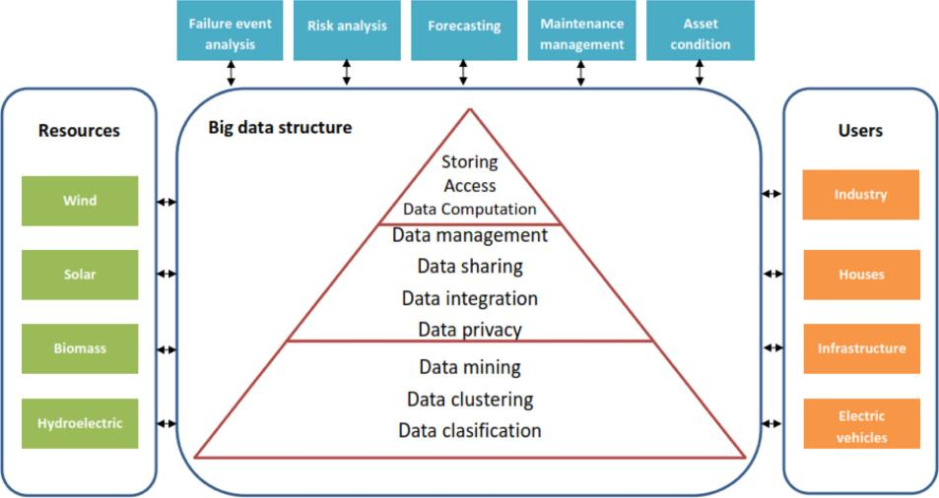
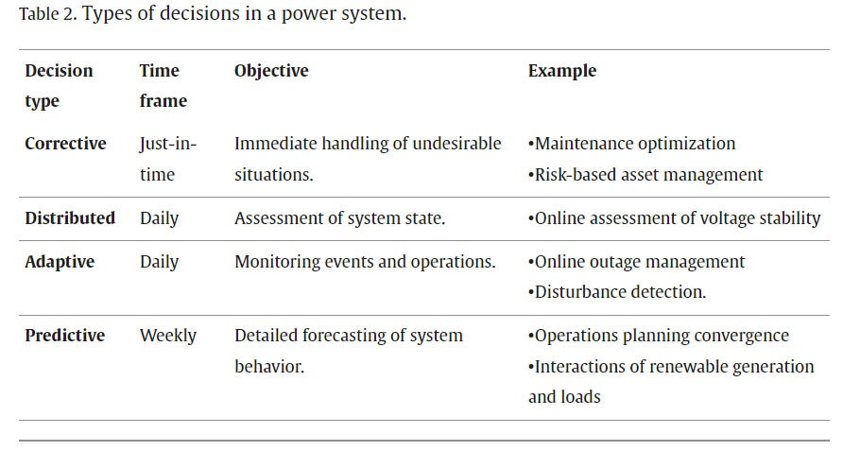
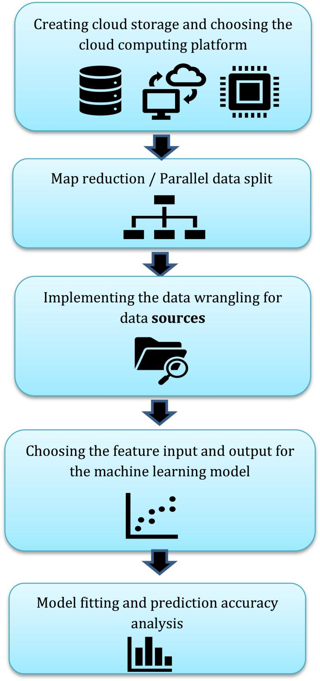
The improvement of smart grid stability can be provided from using the CNN model and setting up the optimal settings from linkage between different power source and consumption outlets. The results have shown an optimized model accuracy and fast processing for the CNN compared to other ML classification algorithms.
Comprehensive review of load forecasting with emphasis on intelligent computing approaches
In this paper, the most important studies conducted in the recent years in relation to the mid-term load forecasting with emphasis of intelligent methods were investigated. The various methods first were classified based on type of techniques, and then the basic new studies were investigated in more details. The main achievements and drawbacks of various methods were discussed and analyzed. Finally, the main suggestions for the future practical applications were summarized. Furthermore, the challenges of fuzzy-neural networks was investigated. The most significant challenge in using the fuzzy-neural networks for modeling and forecasting mid-term load is to determine the type of inputs. In some references, the various economic, social, weather, grid load data indices are used, and in some other references, the validity of such research has been challenged, because the forecasting of economic and climate indices are more difficult than load forecasting.
All these researches have a common point that is using deep learning method to get high accurate result for the data we are using. Some articles implement renewable energy topics some just work on power energy and how efficience it can be. SVM, ANN, CNN and fuzzy-neural networks methods and processes are more accurate in these articles.
- Conclusion:
This literature review pave the way for our current capstone project in which we will be called to use a specific type of model in such way to get high accurate result. Deep Learning might be reasonable option and data processing, model output fixing must be clear. Our project will essentially which variables impact energy and power comsuption and how by balancing inputs we can provide good prices and better alternatives solutions for customers.

Preparing Your Data Research:
Introduction:
The ascent of renewable energy sources provides the global community with a much demanded alternative to traditional, finite and climate-unfriendly fossil fuels. However, their adoption poses a set of new paradigms, out of which two interrelated aspects deserve particular attention:
- Prior to the rise of renewable energy sources, the traditional operating ecosystem involved few production entities (sources) supplying energy to consumers over unidirectional flows. With the advent of renewable options, end users (households and enterprises) now not only consume energy but have the ability to produce and supply it - hence a new term to designate them, 'prosumers'. As a result, energy flow within distribution grids - 'smart grids' - has become bidirectional;
- Despite the increased flexibility brought in by the introduction of renewable sources and the aforementioned emergence of 'prosumers', the management of supply and demand in a more complex generation / distribution / consumption environment and the related economic implications (particularly the decision to buy energy at a given price or not) have become even more challenging.
- Organization:
In a smart grid, consumer demand information is collected, centrally evaluated against current supply conditions and the resulting proposed price information is sent back to customers for them to decide about usage. As the whole process is time-dependent, dinamically estimating grid stability becomes not only a concern but a major requirement. Put simply, the objective is to understand and plan for both energy production and/or consumption disturbances and fluctuations introduced by system participants in a dynamic way, taking into consideration not only technical aspects but also how participants respond to changes in the associated economic aspects (energy price).
It is known that the electrical signal frequency "increases in times of excess generation, while it decreases in times of underproduction" . Therefore, measuring the grid frequency at the premise of each customer would suffice to provide the network administrator with all required information about the current network power balance, so that it can price its energy offering - and inform consumers - accordingly.
The model takes into consideration inputs (features) related to:
- the total power balance (nominal power produced or consumed at each grid node);
- the response time of participants to adjust consumption and/or production in response to price changes (referred to as "reaction time);
- energy price elasticity.
So we have a mathematical model with which grid instability can be predicted! The need of a tool to predict grid instability would have been met, and the binary classification ("stable" versus "unstable") problem would be solved! However, the execution of this model relies on significant simplifications.
In other words, machine learning used will follow this way:
- A given set of input parameters (call it a 'vector') is fed into the original DSGC Decentral Smart Grid Control model;
- The DSGC model process this vector and returns a binary output - the grid stability for that particular set of inputs ('stable' or 'unstable' - a binary classification!);
- Steps 1 and 2 are executed 'n' times;
- A large set of vectors and the respective outputs (stability or instability) is created.
In summary, the original DSGC model was run to generate a set of inputs and outputs that a 'learning machine' can process and make predictions from!
These are the 2 majors objectives:
- Pursue improvements in predictions with deep learning (Keras' Sequential model);
- Take the opportunity to assess the influence of deep learning architecture (number and size of hidden layers), number of epochs and the relevance of dataset augmentation.

- Data Description:
The original dataset contains 10,000 observations. As the reference grid is symetric, the dataset can be augmented in 3! (3 factorial) times, or 6 times, representing a permutation of the three consumers occupying three consumer nodes. The augmented version has then 60,000 observations. It also contains 12 primary predictive features and two dependent variables.
Predictive features:
- 'tau1' to 'tau4': the reaction time of each network participant, a real value within the range 0.5 to 10 ('tau1' corresponds to the supplier node, 'tau2' to 'tau4' to the consumer nodes);
- 'p1' to 'p4': nominal power produced (positive) or consumed (negative) by each network participant, a real value within the range -2.0 to -0.5 for consumers ('p2' to 'p4'). As the total power consumed equals the total power generated, p1 (supplier node) = - (p2 + p3 + p4);
- 'g1' to 'g4': price elasticity coefficient for each network participant, a real value within the range 0.05 to 1.00 ('g1' corresponds to the supplier node, 'g2' to 'g4' to the consumer nodes; 'g' stands for 'gamma');
Dependent variables:
- 'stab': the maximum real part of the characteristic differentia equation root (if positive, the system is linearly unstable; if negative, linearly stable);
- 'stabf': a categorical (binary) label ('stable' or 'unstable').
As there is a direct relationship between 'stab' and 'stabf' ('stabf' = 'stable' if 'stab' <= 0, 'unstable' otherwise), 'stab' will be dropped and 'stabf' will remain as the sole dependent variable.
As the dataset content comes from simulation exercises, there are no missing values. Also, all features are originally numerical, no feature coding is required. Such dataset properties allow for a direct jump to machine modeling without the need of data preprocessing or feature engineering.
- Data Analysis and Insights:
A glimpse at the dataset structure confirms observation shuffling and the close relationship between the two original dependent variables 'stab' and 'stabf'
It is important to verify the correlation between each numerical feature and the dependent variable, as well as correlation among numerical features leading to potential undesired colinearity. The heatmap below provides an overview of correlation between the dependent variable ('stabf') and the 12 numerical features. Note that also the alternative dependent variable ('stab') has been included just to give an idea of how correlated it is with 'stabf'. Such correlation is significant (-0.83), as it should be, which reinforces the decision to drop it. Also, correlation between 'p1' and its components 'p2', 'p3' and 'p4' is above average, as expected, but not as high o justify any removal.
Conclusion:
Notably, the dataset requires no preprocessing or feature engineering due to its inherent characteristics—no missing values, all features are numerical, and a straightforward relationship between the 'stab' and 'stabf' variables. As a result, there is a direct and clear mapping of stability ('stabf') based on the maximum real part of the characteristic differential equation root ('stab'). The decision to drop 'stab' and retain 'stabf' as the sole dependent variable simplifies the modeling process.
These properties streamline the pathway to machine modeling, allowing for a focused exploration of predictive algorithms without the need for extensive data manipulation. The absence of missing values and the numerical nature of features contribute to a robust foundation for building and evaluating machine learning models for stability prediction in the smart grid system.
Proper Citations:
Main reference https://www.kaggle.com/code/mineshjethva/power-grid-stability-with-deep-learning

Preparing Your Technology Review:
Introduction:
- Technology Overview:
The term smart grid (SG) is used to describe the integration of information and digital communication technologies with power grid systems. This enables bi-directional communication and power flow that can enhance security, reliability, and efficiency of the power system. Connectivity lies at the core of this modern grid infrastructure, which is provided by the Internet of Things (IoT). However, constant connectivity and communication introduces a massive data volume that demands techniques far superior to conventional methods to allow for proper analysis and decision-making.
Whilst an IoT-integrated SG system can provide efficient energy transmission, lower management costs, better security and integration of renewable energy, big data analysis and machine learning techniques are essential to realizing these benefits.
Machine learning techniques provide an efficient way to analyze, and then make appropriate decisions to run the grid; and thus enables the smart grid to function as it is intended to. Machine learning functionalities include:
- Predictions of consumption price
- Power generation
- Future optimum scheduling
- Fault detection and
- Detection of network intruders
SG is commonly used cause of this field of machine learning application.
- Relevance to Your Project:
A smart grid is an electricity network that uses digital and other advanced technologies to monitor and manage the transport of electricity from all generation sources to meet the varying electricity demands of end users. Smart grids co-ordinate the needs and capabilities of all generators, grid operators, end users and electricity market stakeholders to operate all parts of the system as efficiently as possible, minimising costs and environmental impacts while maximising system reliability, resilience, flexibility and stability. Most of the technologies involved have already reached maturity, and so tracking investments provides insights on levels of deployment.
Due to the complex nature of smart grid technology, there are manifold opportunities for attackers to disrupt the system. Therefore, a comprehensive defense strategy is required to cover all sorts of threats and vulnerabilities a smart grid can encounter.
Machine learning techniques have been proved to be an especially useful tool to prevent a denial-of-service attack. Machine learning can take detect attacks, take proactive actions to address known issues and notify security administrators.
The migration of the electric sector towards smart grids demands the continuous development of machine learning techniques since their implementation can harmoniously integrate all the components used. This then grants reliability in smart electric systems as well as guaranteeing quality, efficiency and continuity.
- Comparison and Evaluation:
Nowadays, existing power grids are affected by severe drawbacks, such as: 1) fragmented architectures; 2) a lack of adequate bandwidth for achieving two-way communications; 3) a lack of inter-operability between system components; and 4) the inability to handle the increasing amount of data from smart devices. (A Survey on Smart Grid Potential Applications and Communication Requirements by V. Cagri Gungor, Member, IEEE, Dilan Sahin, Taskin Kocak, Salih Ergut, Concettina Buccella, Senior Member, IEEE, Carlo Cecati, Fellow, IEEE, and Gerhard P. Hancke, Senior Member, IEEE )
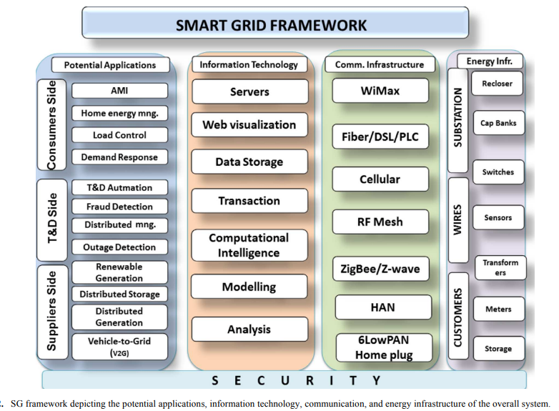
- Use Cases and Examples:
- The Boston Consulting Group (BCG) found that an energy retailer was able to boost its gross margins by more than 20% by creating detailed customer profiles using multiple sources of data to guide pricing increases, targeting those likely to pay and avoiding those at high risk of churn.
- Florida Power and Light was able to use grid data to monitor the status of their grid and operations (particularly from their smart meters) to gain $30 million in operational savings.
- Norway has reached the epitome of clean energy, with over 96% of electricity produced from hydro power, and a goal of selling no fossil fuel-powered cars by 2025. The country is on its way to being the first fully renewable energy-powered nation, and is reaping significant benefits like more efficient energy generation, new jobs in the renewables sector, improved consumer choice in energy and reduced carbon footprint.

- Identify Gaps and Research Opportunities:
Data Quality and Standardization:
Challenge: Smart grids generate vast amounts of heterogeneous data from various sources. Ensuring the quality and standardization of this data can be challenging, potentially leading to inconsistencies and inaccuracies in model training.
Improvement Needed: Implementing robust data quality control measures and standardizing data formats across different components of the smart grid are essential. This may involve the development of industry-wide data standards to enhance interoperability.
Cybersecurity Concerns:
Challenge: Smart grids are susceptible to cybersecurity threats due to their interconnected nature. Unauthorized access, data breaches, and attacks on critical infrastructure pose significant risks.
Improvement Needed: Enhancing cybersecurity measures, including encryption, secure communication protocols, and intrusion detection systems, is crucial. Continuous monitoring and updating of security protocols are necessary to address evolving cyber threats.
Integration of Renewable Energy Sources:
Challenge: The intermittent and unpredictable nature of renewable energy sources, such as solar and wind power, poses challenges for grid stability and balancing.
Improvement Needed: Developing advanced forecasting models that incorporate machine learning algorithms to predict renewable energy generation more accurately. Additionally, integrating energy storage systems to buffer fluctuations in renewable energy production is vital for maintaining grid stability.
Lack of Standardized Communication Protocols:
Challenge: The absence of standardized communication protocols across different components of the smart grid hinders seamless data exchange and coordination.
Improvement Needed: Establishing and adopting common communication protocols can enhance interoperability and facilitate efficient communication between devices and systems within the smart grid.
Scalability Issues:
Challenge: As the scale of smart grid deployments increases, scalability issues may arise in terms of managing and processing the growing volume of data.
Improvement Needed: Implementing scalable and distributed computing architectures can address this challenge. Cloud-based solutions and edge computing technologies may offer scalable alternatives for handling large-scale smart grid data.
Regulatory and Policy Challenges:
Challenge: The regulatory framework for smart grids may not be well-defined or may vary across regions, impacting the implementation of new technologies and practices.
Public Acceptance and Privacy Concerns:
Challenge: Public acceptance of smart grid technologies may be hindered by privacy concerns related to the collection and use of personal energy consumption data.
Improvement Needed: Implementing transparent data privacy policies, ensuring anonymization of sensitive information, and actively engaging with the public to address concerns can help build trust and acceptance.
Conclusion:
The smart grid stands as a crucial tool in the transition to renewable energy and effective energy management. Its adaptability facilitates the seamless integration of renewable sources, while machine learning within the smart grid optimizes resource allocation and enhances grid efficiency. In the context of our project, focused on deep learning for energy optimization, the smart grid is fundamental. It not only enables the integration of renewable energy but also empowers intelligent strategies to reduce wastage, aligning with our goals of efficiency and sustainability. The smart grid is not just a technological advancement; it's a strategic enabler for a resilient and sustainable energy future.
  - Proper Citations:
- Ensure that you provide proper citations for any external sources, research papers, or references you have used in your technology review. Proper citations are essential for acknowledging the sources of information.

